Interfolio Faculty Search
User Guide
Submitting an Applicant for Approval to Hire
Approving a Selection
Sending a Selection Back
July 9, 2020
Baylor University

Submitting an Applicant for Approval to Hire
At the end of a search, committee managers and administrators can close a position and indicate whether or not they have selected one or more applicants to fill the position.
Baylor has established a workflow for approving selections. You will need to submit your selections for approval in order to ensure that all academic hires follow Baylor’s policies regarding faculty hires.
The steps below describe the process of closing a position and submitting selected applicants for approval

Navigate to the position you want to close
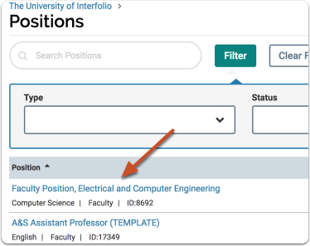
Select the position by clicking on the link as identified above.
Add and/or Verify required documents have been added
Select the name of the Applicant(s) you plan hire. Scroll down to internal documents. Select Add file and attach the following documents:

- Hiring Proposal Document (attach post-interview)
- Faculty Certification of Credentials form (Found on the provost’s website) (attach pre- interview)
- Religious Affiliation Form (Found on the provost’s website) (attach post-interview – Melissa Stone will handle this attachment)
- Certified Transcript (attach post-interview)
- Other(s) (If applicable) – Example: Justification for Endowed Chairholder Status

Once required internal documents have been attached, Click "Close Position" under the "Position Actions" menu at the top right of the screen
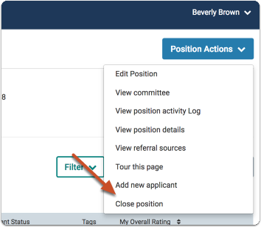

If you have identified an applicant to hire, select “Yes”.
If one or more applicants was selected to fill the position, click "Add Applicant"
If you indicated a selection was made, you must select at least one applicant to continue.

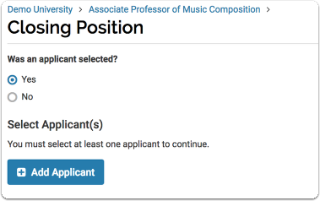
A list of available applicants will appear in a window. Find the name of the applicant(s) you want to hire and click "Add".
You can sort the list of applicants by name, email, and status. You can also search the list by name or email address and filter the list by status.
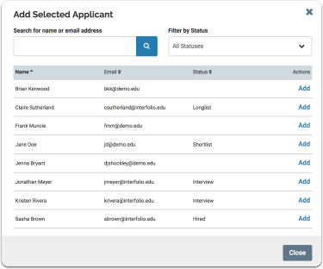

Once you have selected the applicant(s), Click "Close Position" to send and submit the selected applicants for approval through the established workflow.

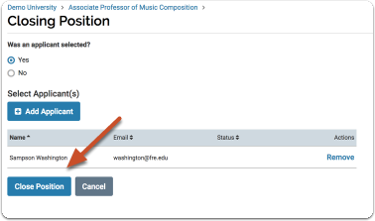

This opens a page that lists the approver(s) for the selection.
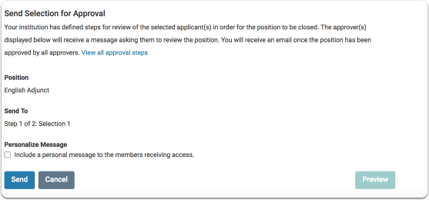

The approver(s) displayed will receive an email indicating that a selection has been made and is awaiting their approval.
You can personalize this email with a message to the approver.
If you do not include a message, you must unclick the personalize message box or you will not be able to send the approval to the next step in the workflow.
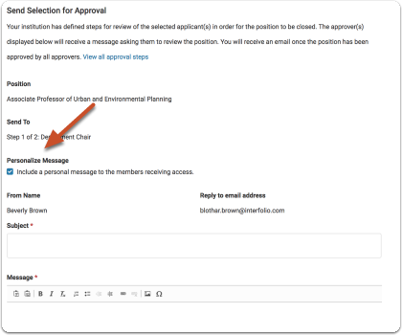

Note that you can click a link to view all the selection approval steps in the process

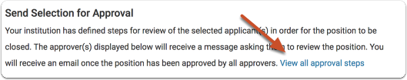
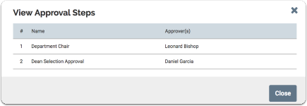

Click "Send" when you are ready to submit the selection for approval
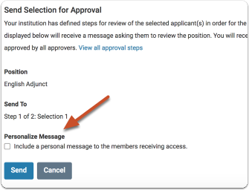

Approving or Sending Back a Selection for Hire
This section explains the process of approving or sending back the workflow related to hiring an applicant that has been selected. If you are an administrator who is assigned to the workflow process, follow the instructions below to approve or send back the hiring selection.
Approving an applicant selected for hire
If you are assigned to approve selections, you will receive an email like the one below notifying you that a position (selection) requires your approval.
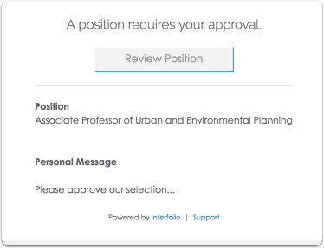
Clicking "Review Position" opens the selection approval page that displays the current step, who the step is assigned to, and instructions for the approval.
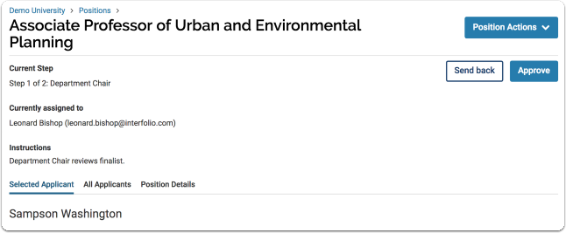
Scroll down to the tabbed section of the page. The "Selected Applicant" tab displays the selected applicant's information and application materials. Scroll down to the “internal documents” section to review the hiring proposal and other required documents.
REQUIRED DOCUMENTS that should be attached and reviewed in the “internal documents” section before the applicant approval is sent through to the next step in the process. Documents are as follows:
- Hiring Proposal Document (attach post-interview)
- Faculty Certification of Credentials form (Found on the provost’s website) (attach pre- interview)
- Religious Affiliation Form (Found on the provost’s website) (attach post-interview – Melissa Stone will handle this attachment)
- Certified Transcript (attach post-interview)
- Other(s) (If applicable) – Example: Justification for Endowed Chairholder Status
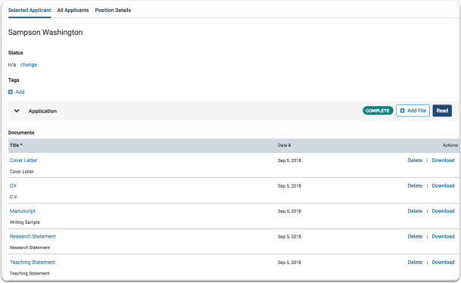

Note that the "Position Details" tab displays basic position information.
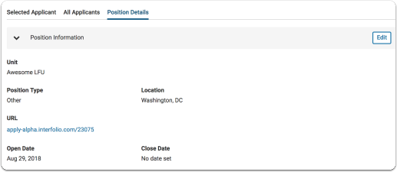

Once the documents have been reviewed, Click “Approve” to send the hiring recommendation through to the next step in the workflow.
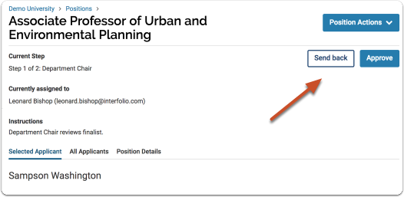

You can personalize the email that will be sent alerting approver(s) at the next step in the workflow that a selection requires approval.
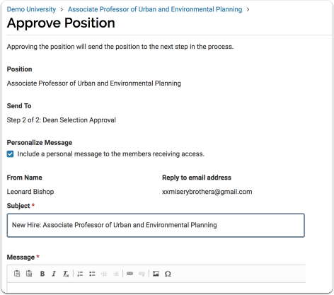

If the position is at the final step in the approval process, click "Close" to approve and close the position
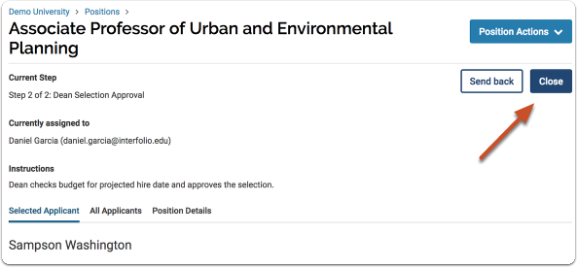

Sending Back a Position
If a selection is not approved, click “Send Back” to return the hiring selection back to an earlier step for correction or changes.
Note: With POSITION approval, you can send your position back to a previous step in the workflow and when it's resolved, it will return to the step that sent it back.
For HIRING SELECTION approval, when you send your position to a previous step in the workflow, it will need to go through all the steps in the built-out workflow.
For example, if your selection was sent from step 3 of the process to step 1, the selection will have to go back through steps 1, 2, and 3.
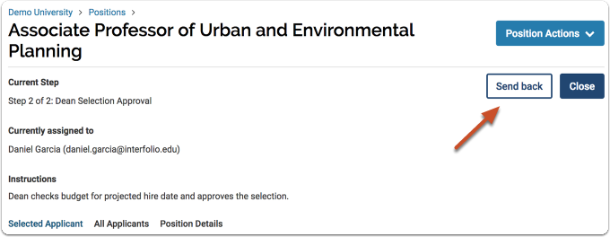

Indicate the step you are sending the position to and personalize the message that will alert approvers at that step.
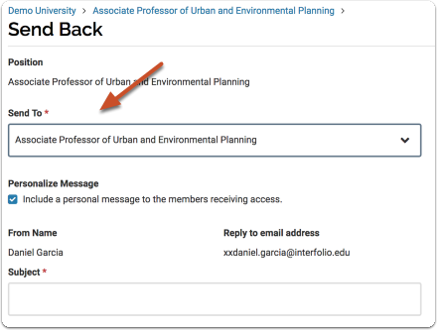

Approvers at that step will receive an email indicating that a position requires their attention
